**Elastic Beanstalk**

**Problem Statement:**

**You work for XYZ Corporation. Your corporation wants to launch a new**

**web-based application and they do not want their servers to be running all the**

**time. It should also be managed by AWS. Implement suitable solutions.**

**Tasks To Be Performed:**

**1. Create an Elastic Beanstalk environment with the runtime as PHP.**

**2. Upload a simple PHP file to the environment once created**

**1. Create an Elastic Beanstalk environment with the runtime as PHP.**

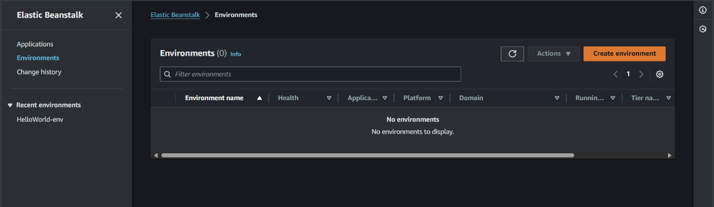

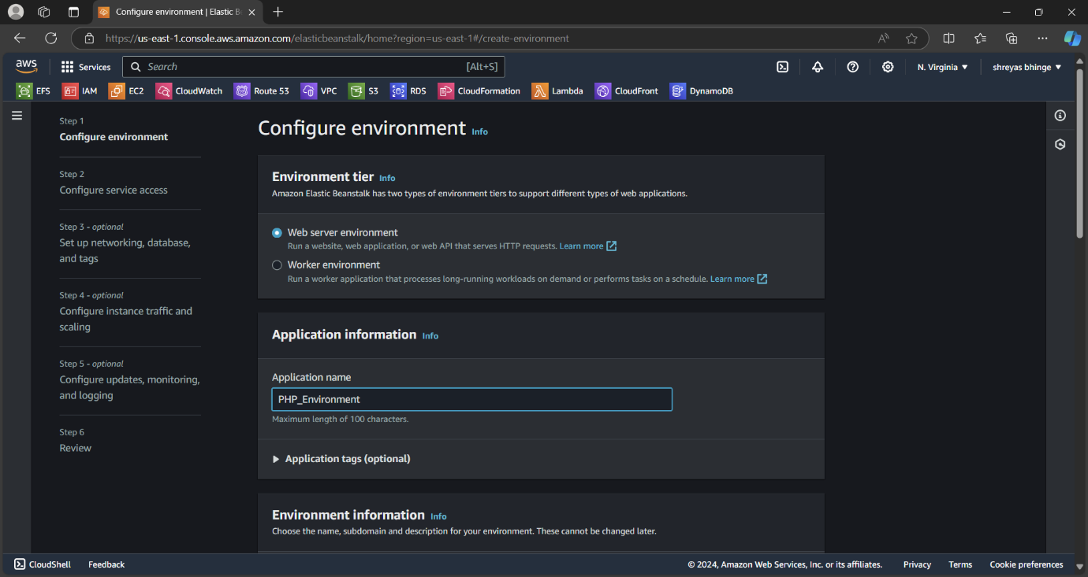

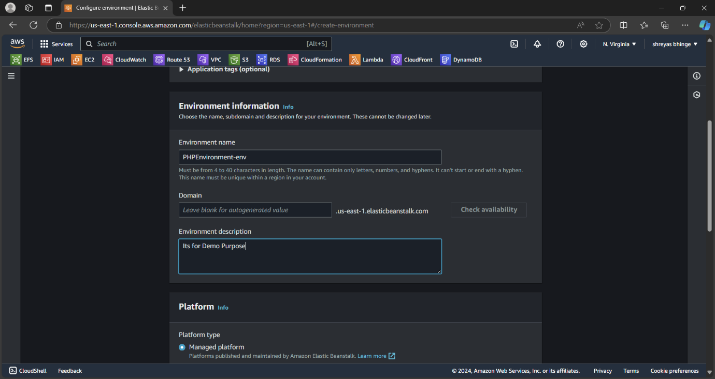

**2. Upload a simple PHP file to the environment once created**

